Alg 3 Summer Name: ____________________________

______________ _____________
WS Assessment
Target 9:
Function family
Basic transformation
I can:
- Identify basic function family – parent graph.
- Use function notation for basic transformation
- Graph square root, cube root and absolute value function
- Unit 4: Parent Graphs & Their Transformation

HSF.IF.B.4: For a function that models a relationship between two quantities, interpret key features of graphs and tables in terms of the quantities, and sketch graphs showing key features given a verbal description of the relationship. Key features include: intercepts; intervals where the function is increasing, decreasing, positive, or negative; relative maximums and minimums; symmetries; end behavior; and periodicity.*

HSF.IF.C.7: Graph functions expressed symbolically and show key features of the graph, by hand in simple cases and using technology for more complicated cases.*

HSF.IF.C.7.B: Graph square root, cube root, and piecewise-defined functions, including step functions and absolute value functions.
- HSF.BF.B.3: Identify the effect on the graph of replacing f(x) by f(x) + k, k f(x), f(kx), and f(x + k) for specific values of k (both positive and negative); find the value of k given the graphs. Experiment with cases and illustrate an explanation of the effects on the graph using technology. Include recognizing even and odd functions from their graphs and algebraic expressions for them.

Basic function families
With two pieces of blank papers, you divide and cut each into six equal parts. Now you have 12 separate pieces. On each pieces of paper, write and sketch one of the following functions (12 pieces = 12 functions). Using Zoom Standard Windows for viewing and drawing

A. y = x² + 2 | B. y = x³ – 4 | C. y = 2^{x} | D. y = x
E. y = - x / 3 – 2 | F. y = x³ | G. y = (x – 2)² – 3 | H. y = 2^{(x + 3)} + 2
I. y = 2^{x} – 3 | J. y = (x – 1)³ + 2 | K. y = x / 2 + 1 | L. y = x²

After you have done the drawing, base on its shapes, sort them into four groups. We call this family.
There are four family of functions that you suppose to know before getting to this class (we will learn few more family before you leave this class).

In each family below, arrange the function in order from the simplest to more complicated.
The simplest function is called the parent. Usually, it does not have any attach number beside the x and the y. The other functions are called children in the family. They are obtained by moving a parent around (called transformation, which we will learn later).

Linear Family  Parent: _____________________________  Child 1 _____________________________  Child 2 _____________________________ | Quadratic Family (Parabola)  Parent: _____________________________  Child 1 _____________________________  Child 2 _____________________________
Cubic Family (S shape)  Parent: _____________________________  Child 1 _____________________________  Child 2 _____________________________ | Exponential Family  Parent: _____________________________  Child 1 _____________________________  Child 2 _____________________________

1. What is the common characteristic of the parent function?

2. What is the difference between parent and child function?

Function Transformation: Explain the transformation that is performed here:
orginal graph | transformation
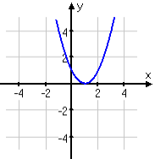 | 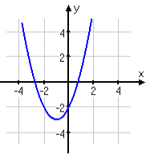 | The graph is shifted by _____up / down (choose one) and ____left / right  The original function is Y1 = (x – 1)², What is the transformed function Y2 =? _____________________  Graph both of them on calculator, adjust window as indicated then show me for stamp
Stamp: ________________________________________
2. We use f(x) notation instead of y to show the transformation.
What is the transformation? Write the new function for each of them
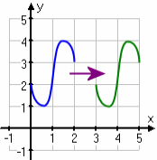f(x) → _________________? | 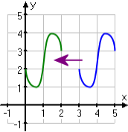  f(x) → _________________? | 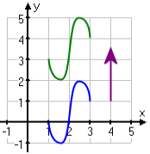f(x) → _________________?
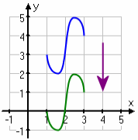f(x) → _________________? | 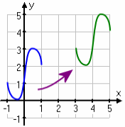  f(x) → _________________? | 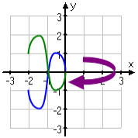  f(x) → _________________?
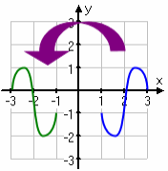f(x) → ________________? | 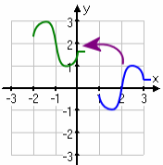f(x) → _________________? | f(x) → 3 – f(3 – x)

Given a quadratic function f(x) = 2(x – 2)² + 3. What is the vertex of this function? (____, ____)
Now translate this function 3 to left and 2 up. Write the transformation both ways: equation and function notation. Graph to check

Now you do. Given g(x) = 2(x + 2)² – 3.
What is the vertex of this function? (____, ____) Now translate this function 3 to right and 2 down. Write the transformation both ways: equation and function notation. Sketch and show me for stamp.

Write and sketch the parent of the following family
Square Root  f(x) = | Cube Root  f(x) = | Absolute  f(x) = | Logarithm  f(x) =
Pick a parent of non-linear function from your learnt families. Do three types of transformation. Write, sketch and show me for stamp

Parent f(x) =
Transformation 1: ___________ 2: _____________ 3: ________________
Child g(x) =

Pick another parent of non-linear function from your learnt families. Do four types of transformation. Write, sketch and show me for stamp

Parent f(x) =
Transformation 1: ___________ 2: _____________ 3: ____________ 4: __________
Child g(x) =

Assessment Target 9
I can… recognize parents and child the basic functions as well as perform basic transformation
1. Name, write the parent and graph all EIGHT basic functions you have learned on this Target

2. Given a cubic function, you will create its 3 children function, where
Parent f(x) = _______________________
Child 1 is horizontal shift left/right by _________ units g(x) = __________________________
Child 2 is vertical shift up/down by ________ units h(x) = ___________________________
Child 3 is horizontal shift left/right by __________ , vertical shift up/down by ________ and reflect over x-axis. k(x) = ___________________________________________
Graph them all in one window here. Identify which one is which and show me for stamp

